# Question #6

## Filter Comparison – LKF vs EKF

For this series of measurements and initial conditions the filters had no significant difference performance in predicting the measurements. This is known be referring to the Figure 1 which shows the NIS test results. We can see that since we only have the ground truth measurement data to work with, the LKF and EKF perform comparably and effectively within the given time limit of the operation to estimate the sensor datas. This is known because the LKF and the EKF both pass the NIS tests within the time limit.



Figure – NIS test results for LKF and EKF given ground truth measurement data

Next, we compare the state trajectory estimates obtained by running the LKF and EKF estimators. For this, we keep the finalized tuned parameters the same as in Question 4 and Question 5. Since we do not have ground truth data for the states, we cannot compare the state estimate errors and only the state estimate error covariances. The basis of comparison here will be how well the state estimates are bounded within the 2 $σ$ bounds: are the state estimates smooth, are the bounds converging etc.

Referring to Figure 2 and Figure 3 we see that EKF is superior in predicting the states compared to the LKF because the 2 $σ$ bounds converge faster, and if we draw our attention to the graphs for $θ_{a}$ we see that the LKF’s the estimate is not stable while the EKF’s is. By this, we mean that at time 90s, the state estimate for $θ_{a}$ with the LKF is an outlier and forms a discontinuity with the current state trajectory. This results in the sudden ‘jump’ in the LKF’s graph while this is not present in the EKF’s graph.

If we go back to the conclusions derived in the previous sections (Question 4 and Question 5) we know that the EKF is superior to the LKF for this nonlinear system. We found that although the LKF and EKF both provide an accurate estimate for the measurements, the EKF performs far better in predicting the system’s states because the state estimate errors were averaging and converging to zero, and the covariance bounds for the estimates were also stable and converging. This was not the case with the LKF as the estimate errors for the position states for the UGV and the UAV did not average to zero and deviated as time progressed.

Returning to the current problem, since we do not have a ground truth state trajectory to compare our results, with the limited information for comparison, we can conclude that the EKF performs better than the LKF for this cooperative localization nonlinear problem.

Refer to Appendix F for codes adhering to this question.

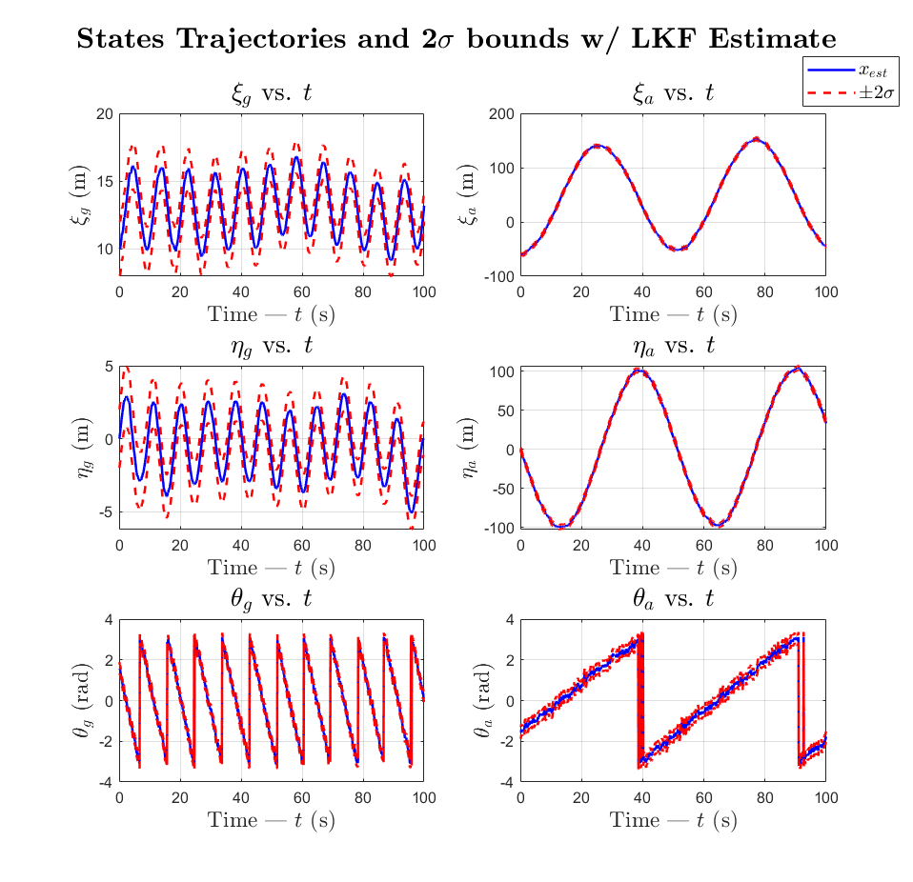

Figure – Estimated state trajectories and 2 $σ$ bounds using the LKF estimator

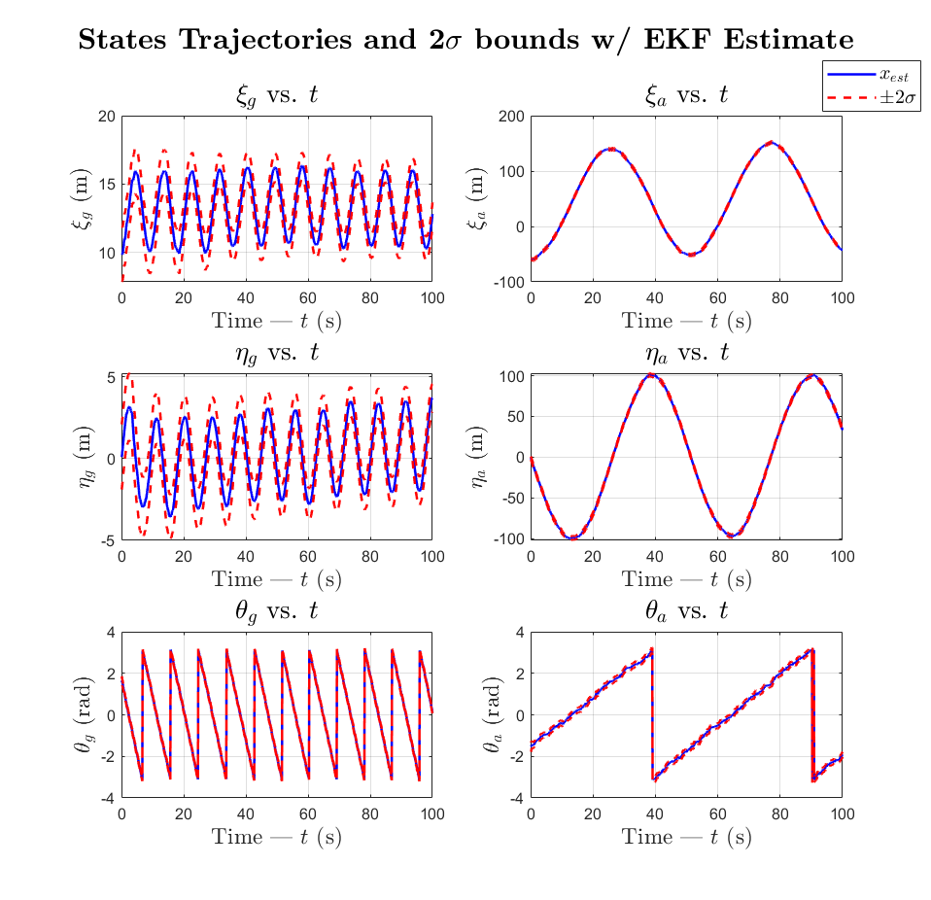

Figure – Estimated state trajectories and 2 $σ$ bounds using the EKF estimator